Janice L. Dennie
ROMANCE AUTHOR

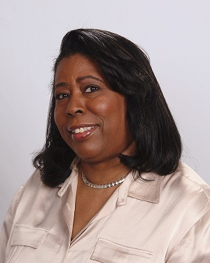

Romance readers everywhere are enamored of Janice L. Dennie’s handsome heroes and feisty heroines as they tumble breathlessly in love among the pages of exciting stories. With a luxuriant voice and style reminiscent of the great romance writers, Ms. Dennie’s romances are dishes of luscious ice cream with candy sprinkles that keeps readers coming back for more of her smooth literary desserts!

Ms. Dennie attended middle and high school in San Francisco, California, where she later graduated from California State University, Hayward, with a Bachelor of Science in Business Administration and began a career with a federal agency.

Ms. Dennie treks to Africa in her LION OF JUDAH SERIES, a set of contemporary and historical romances highlighting Ethiopia’s ruling monarchy that originated with the union between the biblical King Solomon and the Queen of Sheba.

Ms. Dennie returns to America in her newest series, THE UNDERWOOD’S OF NAPA VALLEY, heartwarming romances woven into the gorgeous tapestry of the wine industry, its lush vineyards and the elegant men and women who still believe in the power of love!

Stamped with her signature of excellence, Ms. Dennie writes romance novels that have readers reaching for her books time and again as she delivers love stories featuring beautiful, independent women and tall, dark and dangerous men. Ms. Dennie has made a big splash in a big pond—not bad for a woman who read her first romance novel at 21!

Determined to enjoy her life as she writes her way to the top of the bestseller lists, Ms. Dennie enjoys watching football with her husband, Gregory, and family. Yet she still has time to garden, volunteer in her community, and read her beloved romance novels!

To learn more about Janice L. Dennie and her books, visit www.JaniceDennie.com and indulge in delicious claret of literary pleasure!

